

***Artificial Intelligence (Lab)***

***Assignment - 1***

**Name:**

Ali Maqsood.

**Roll no:**

SU92-BSAIM-F23-050.

**Department:**

Software Engineering Department.

**Program:**

Artificial Intelligence.

**Section:**

BSAI-3A

**Question # 1:**

Today's project is actually a very common interview question, which revolves around a childhood counting game called Fizz Buzz.

**Code:**

import random

def mini1():

    print("Welcome to Fizz And Buzz.")

    print("There will be 5 rounds in total.")

    print("Rules:")

    print("\t 1. If the number is divisible by 3, Enter Fizz.")

    print("\t 2. If the number is divisible by 5, Enter Buzz.")

    print("\t 3. If the number is divisible by both 3 and 5, Enter FizzBuzz.")

    print("\t 4. If the number is not divisible by 3 or 5, Enter None.")

    times=1

    a1=0

    while times<=5:

        guess=random.randint(0,50)

        a2=a1

        a1=guess

        print(f"Guess: {guess}")

        user_guess=input("Enter your guess: ").lower()

        if user_guess=="fizzbuzz" and (a1+a2)%3==0 and (a1+a2)%5==0:

            print("Correct")

        elif user_guess=="fizz" and (a1+a2)%3==0:

            print("Correct")

        elif user_guess=="buzz" and (a1+a2)%5==0:

            print("Correct")

        elif user_guess=="none" and (a1+a2)%3!=0 and (a1+a2)%5!=0:

            print("Correct")

        elif user_guess != "none" and user_guess != "fizz" and user_guess != "buzz" and user_guess != "fizzbuzz":

            print("Invalid Input! Game Over ~~ XD")

            break

        else:

            print("Wrong")

        times+=1

mini1()

**Output:**

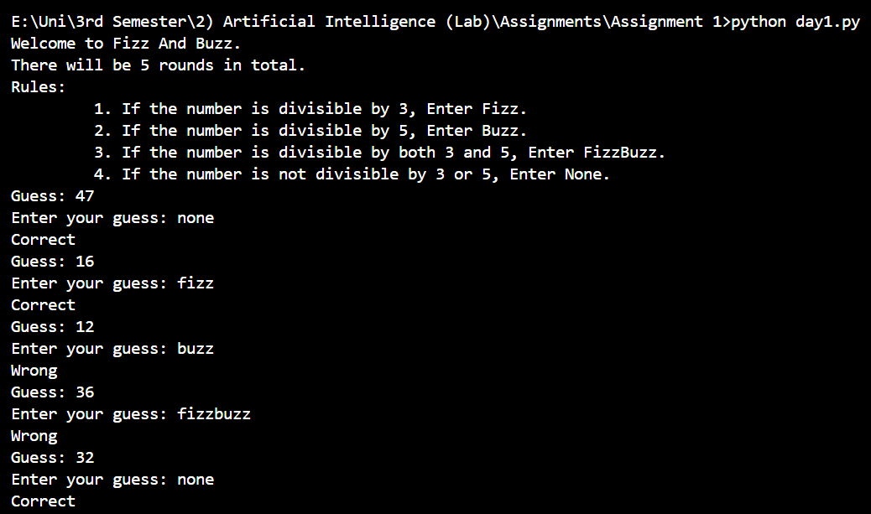

**Question # 2:**

For this project, your program should do the following:

Calculate the average budget of all movies in the data set.

Print out every movie that has a budget higher than the average you calculated. You should also print out how much higher than the average the movie's budget was.

Print out how many movies spent more than the average you calculated.

If you want a little extra challenge, allow users to add more movies to the data set before running the calculations.

**Code:**

def mini2():

    movies = [

    ("Eternal Sunshine of the Spotless Mind", 20000000),

    ("Memento", 9000000),

    ("Requiem for a Dream", 4500000),

    ("Pirates of the Caribbean: On Stranger Tides", 379000000),

    ("Avengers: Age of Ultron", 365000000),

    ("Avengers: Endgame", 356000000),

    ("Incredibles 2", 200000000)

    ]

    input1=int(input("Enter the number of movies: \n"))

    for i in range (input1):

        movie_name=input("Enter the movie name: ")

        movie_budget=int(input("Enter the movie budget: "))

        print("\n")

        movies.append((movie_name,movie_budget))

    print("Calculating Average Budgets.....\n")

    total=0

    for i in range(len(movies)):

        total = total + movies[i][1]

    avg=total/len(movies)

    print(f"The average budget of the movies is {int(avg)}\n")

    print("The movies that are above Average Budget:\n")

    total_abv_avg=0

    for i in movies:

        if i[1] > avg:

            print(f"Name: {i[0]}.")

            print(f"Budget: {i[1]}.\n")

            total_abv_avg+=1

    print(f"Total number of movies above average budget: {total_abv_avg}.")

mini2()

**Output:**

